**MARVIN B. WARO**

**BSCS 3B**

**ACTIVITY 1 – DOWNLOADING AND INSTALLING PYTHON**

**STEP AND PROCESS:**

**STEP 1:** Open your browser and look for “python download” after that you’ll be redirect from the image below in here you will be going to choose versions of python, but the latest is 3.10.6 we must get that for best outcome.

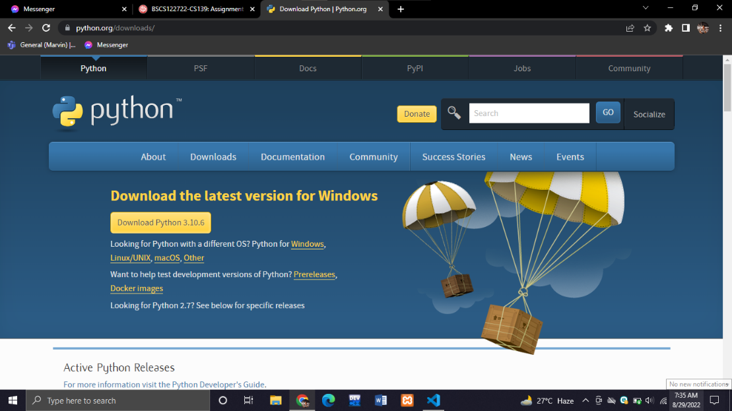

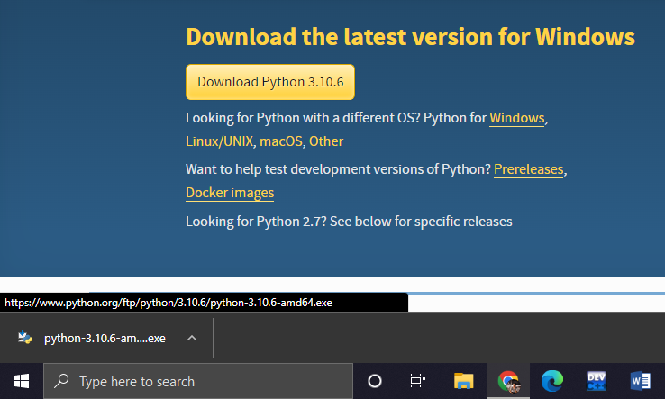**STEP 2:** As you can see from the image below we are done now in downloading python, after you download it click the file on the left corner below and start installing it.

**STEP 3:** Then upon clicking the file you’ll be routed here, then from here start installing python by clicking **‘Install Now’**

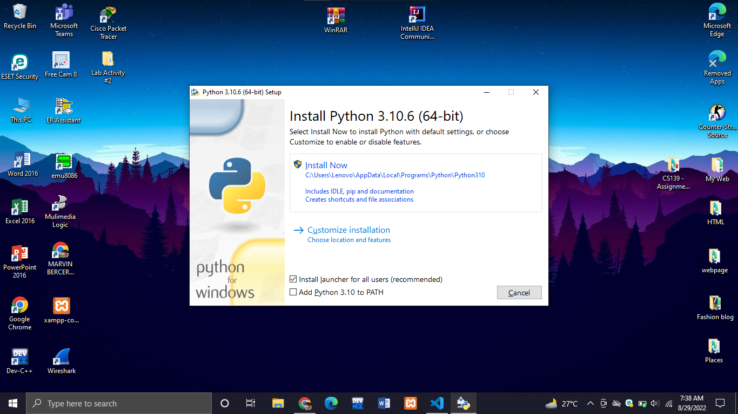

**STEP 4:** After you click the install now just wait for the setup progress to finish installing. Assuming that it’s already finished closed the tab and go to command prompt and type

**Python – version** to be able to know if it is already installed

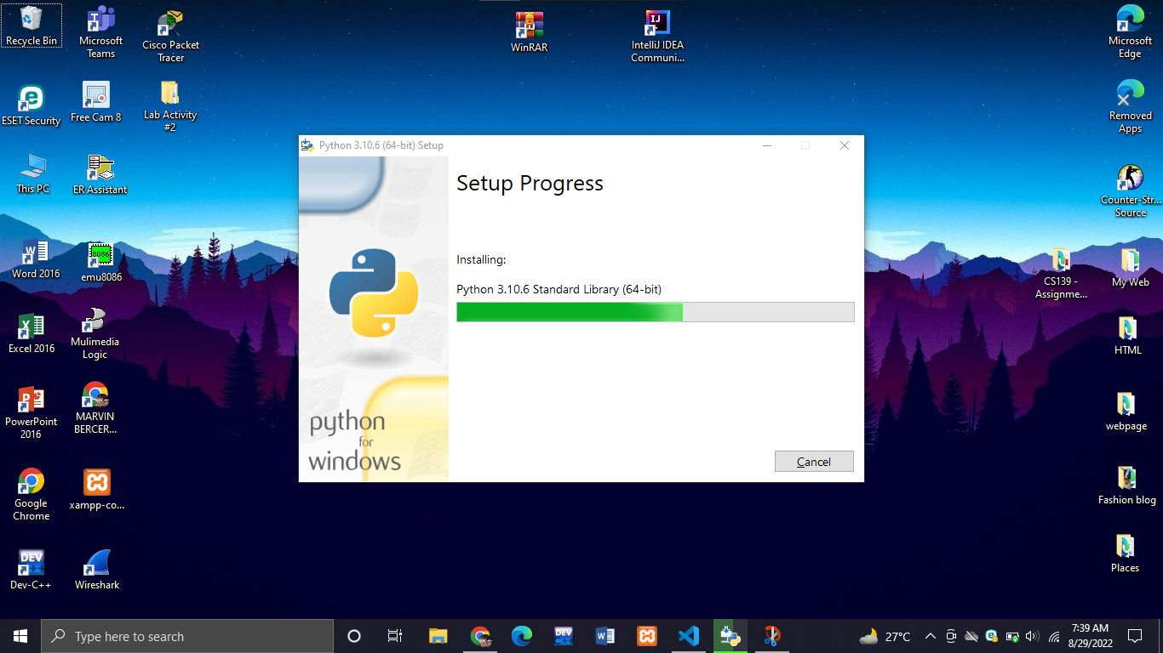

**STEP 5:** We’ve now finish installing python the next thing we need to install is the python IDE or interpreter. So to do that first go again to our browser and search for PyCharm IDE in JetBrains webpage and then click **DOWNLOAD.**

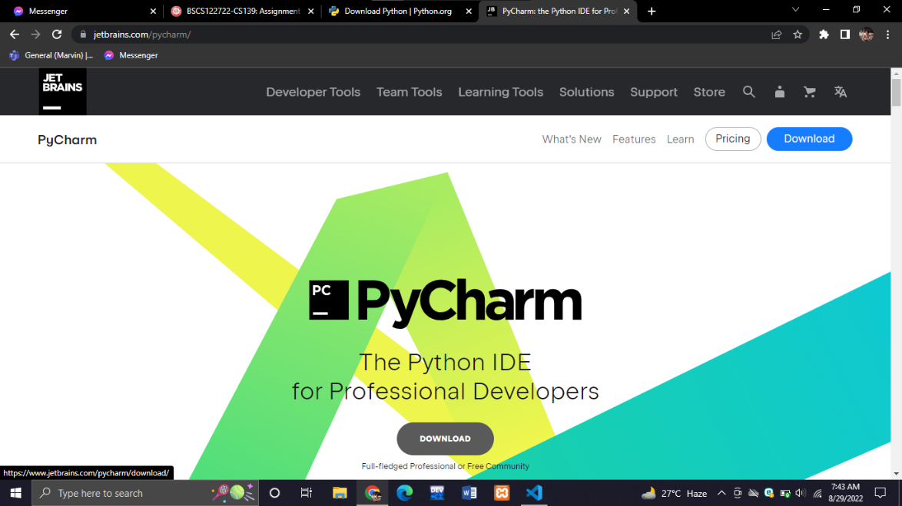

**STEP 6:** Upon clicking the download button you will see in the next page 2 kinds of download, in the left side is a premium & for professionals, and on the right side is the community this is free open source ide for everyone, so we will be choosing the **COMMUNITY DOWNLOAD** because it’s free.

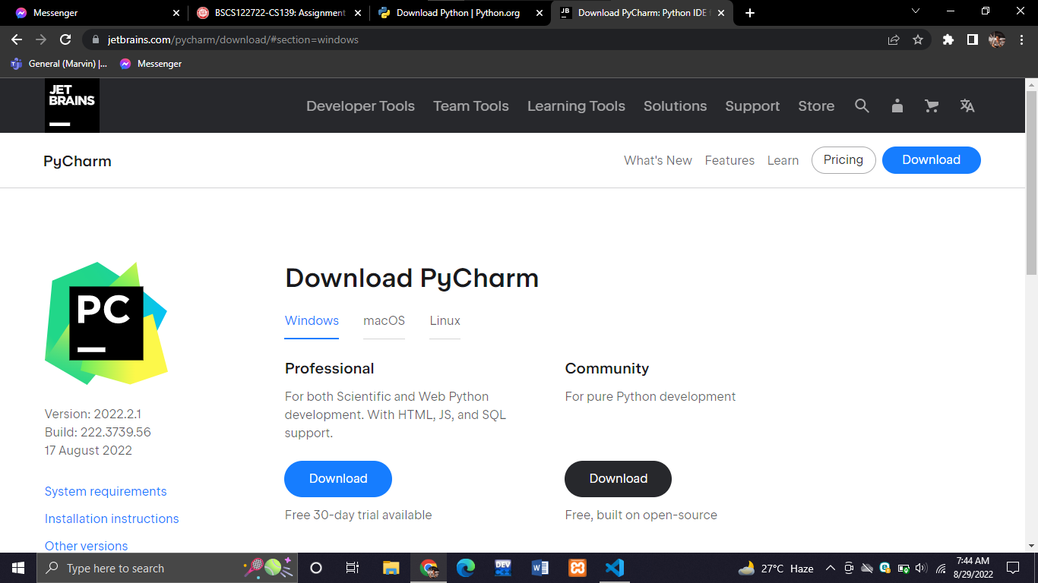

**STEP 7:** Click the downloaded file below and start installing it!

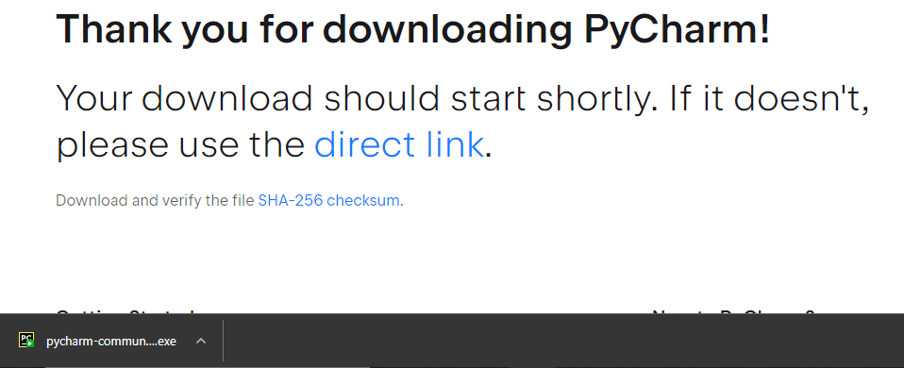

**STEP 8:** Upon clicking the downloaded file you’ll be redirect to the PyCharm setup where you can modify the file location of the PyCharm. From here the things you need to do is click the next button and so on.

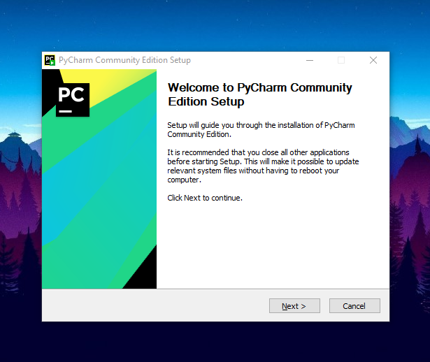

**STEP 9:** So this is the Final Phase after you click the next button for many times, in here you only need to wait up until this installation will be finished and click next and done.

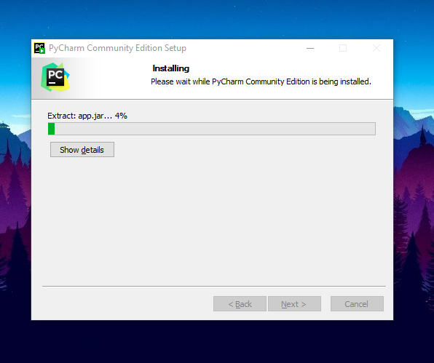

**STEP 10:** After finishing installing PyCharm you can find it on your desktop screen and open it

And then try to Run some code in the IDE by printing Hello World / Hello Python just like the image below

